**SnowSQL download and Install**

**Once you open a free trial account. Then download and install snowsql**

<https://developers.snowflake.com/snowsql/>

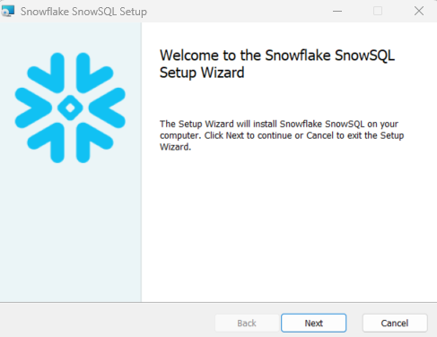

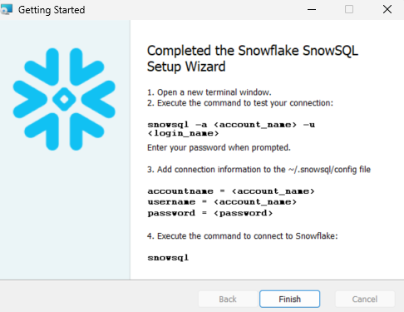

Open the command prompt

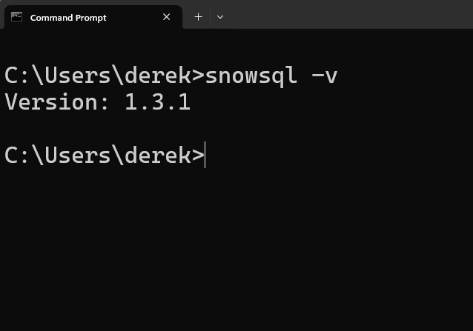

Go to your invitation mail from snowflake and copy this link in a text editor

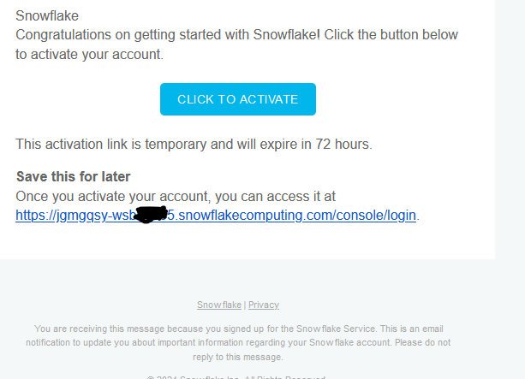

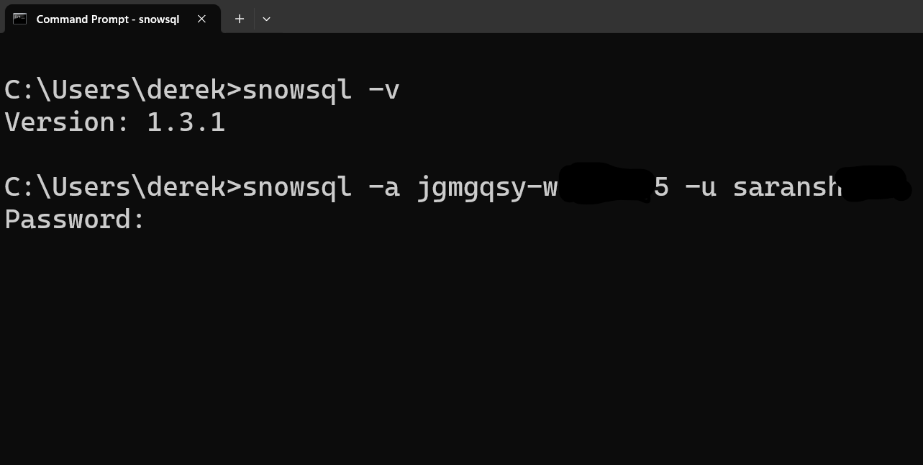

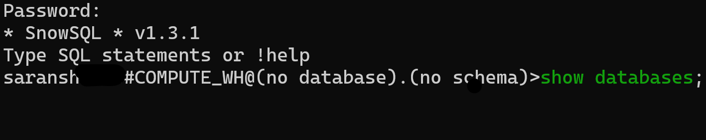

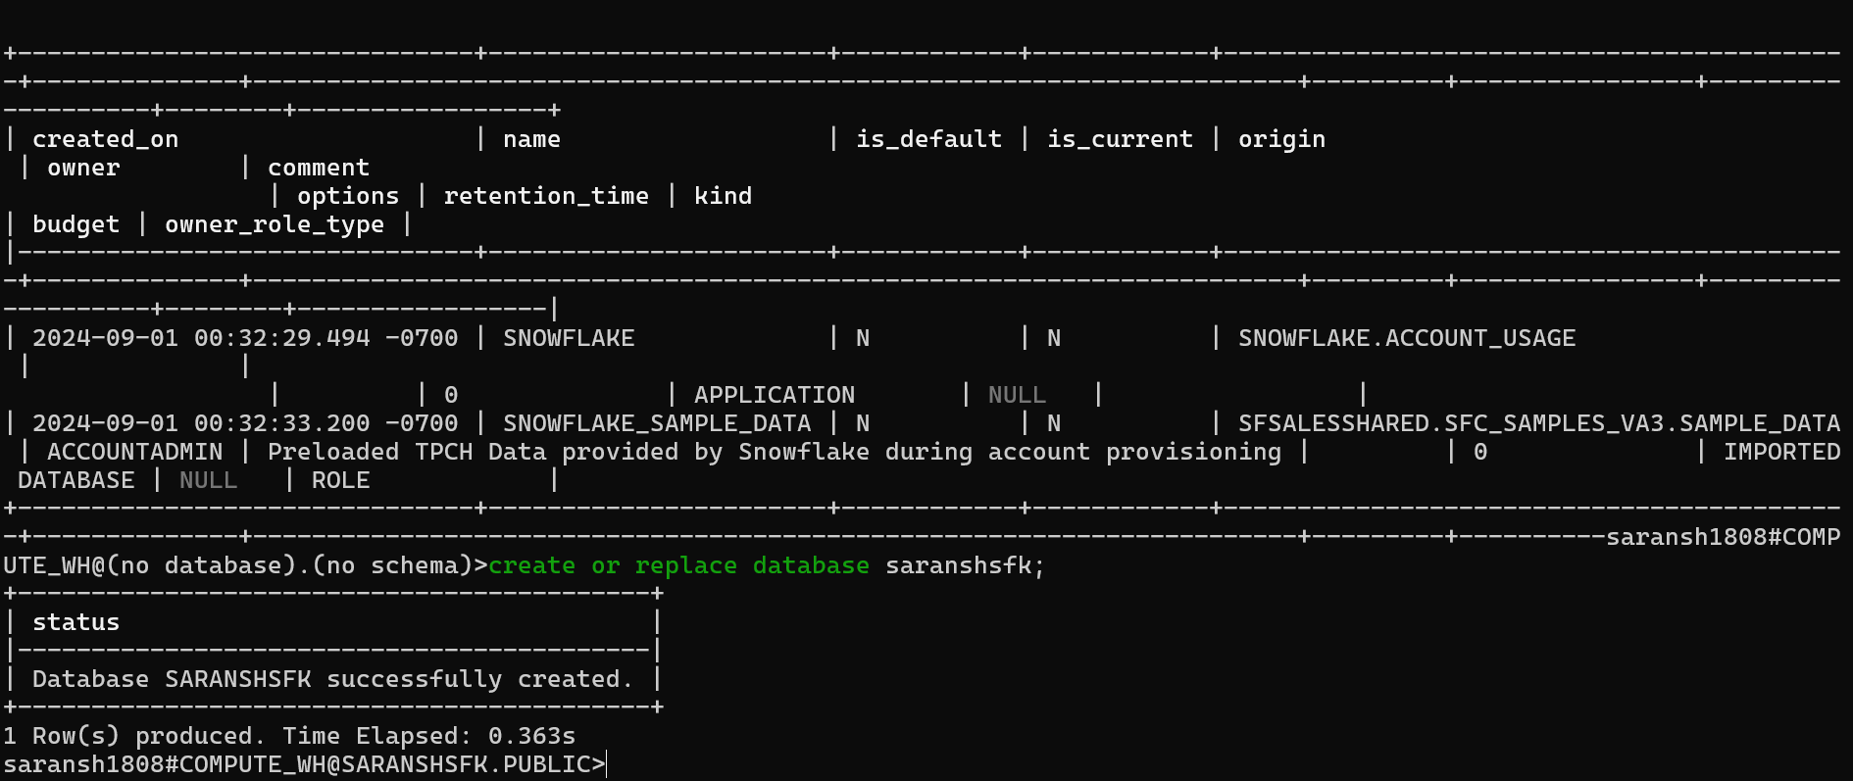

Go to the below file location and open the config file with the text editor

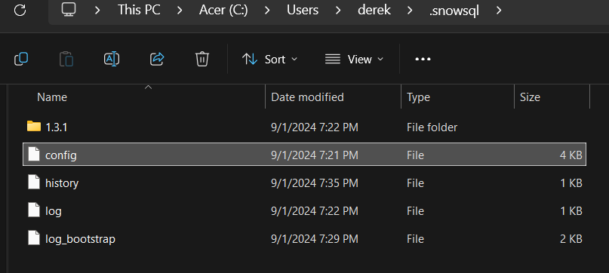

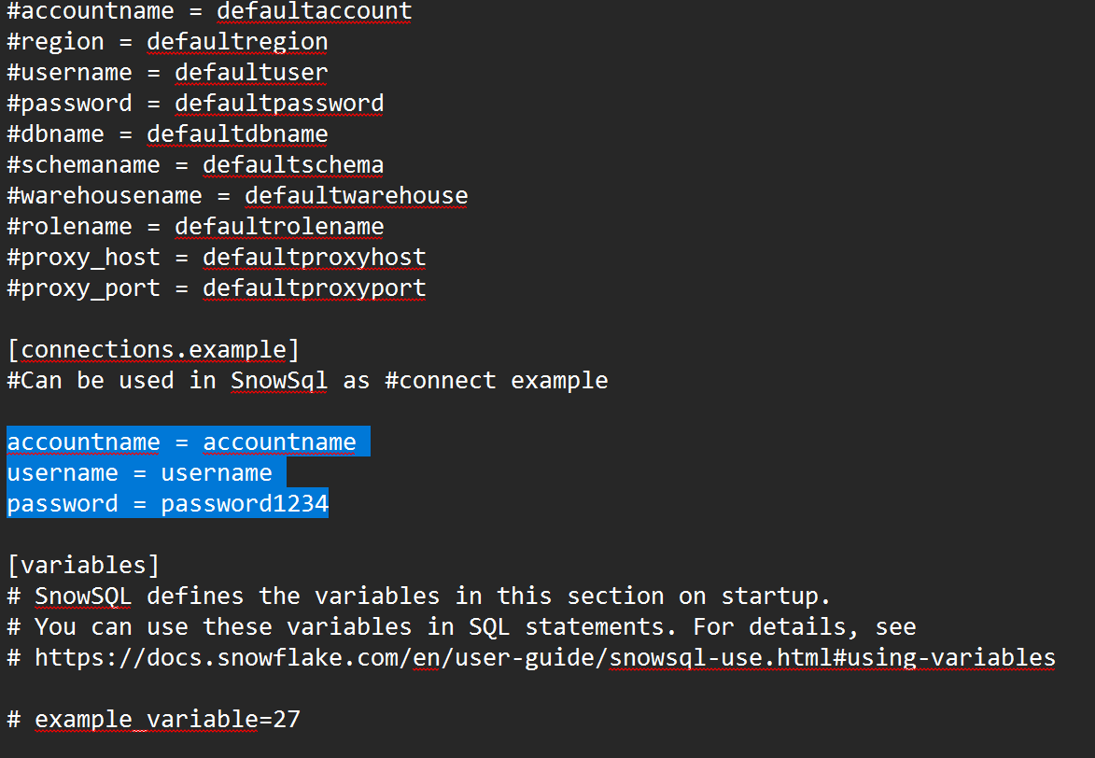

Edit connections.<test>, accountname, username, pass,dbname, warehouse(leave it default). Save your config file and open a new cmd prompt

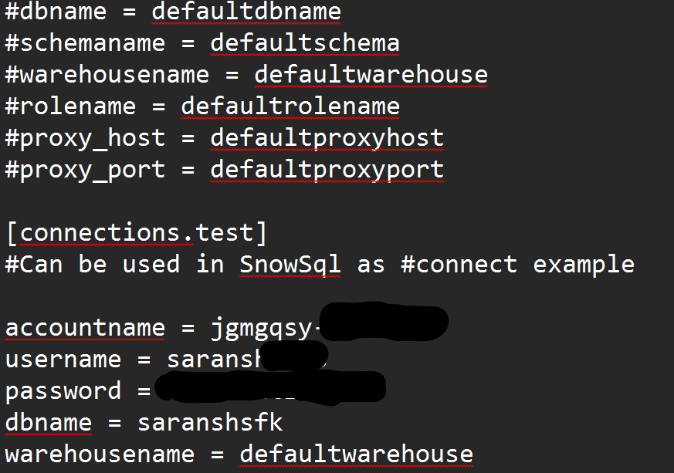

Close the current command prompt window and open a new cmd

In a new command prompt window:

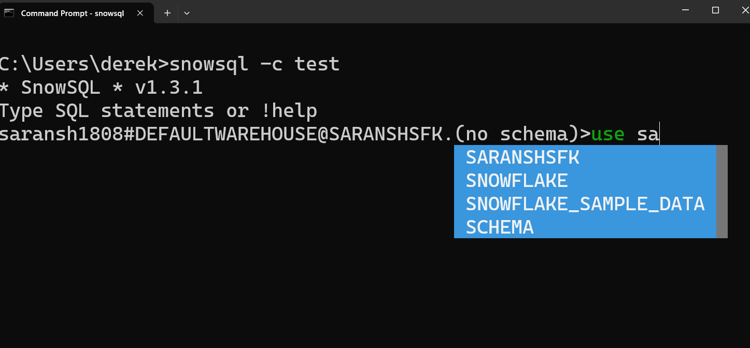

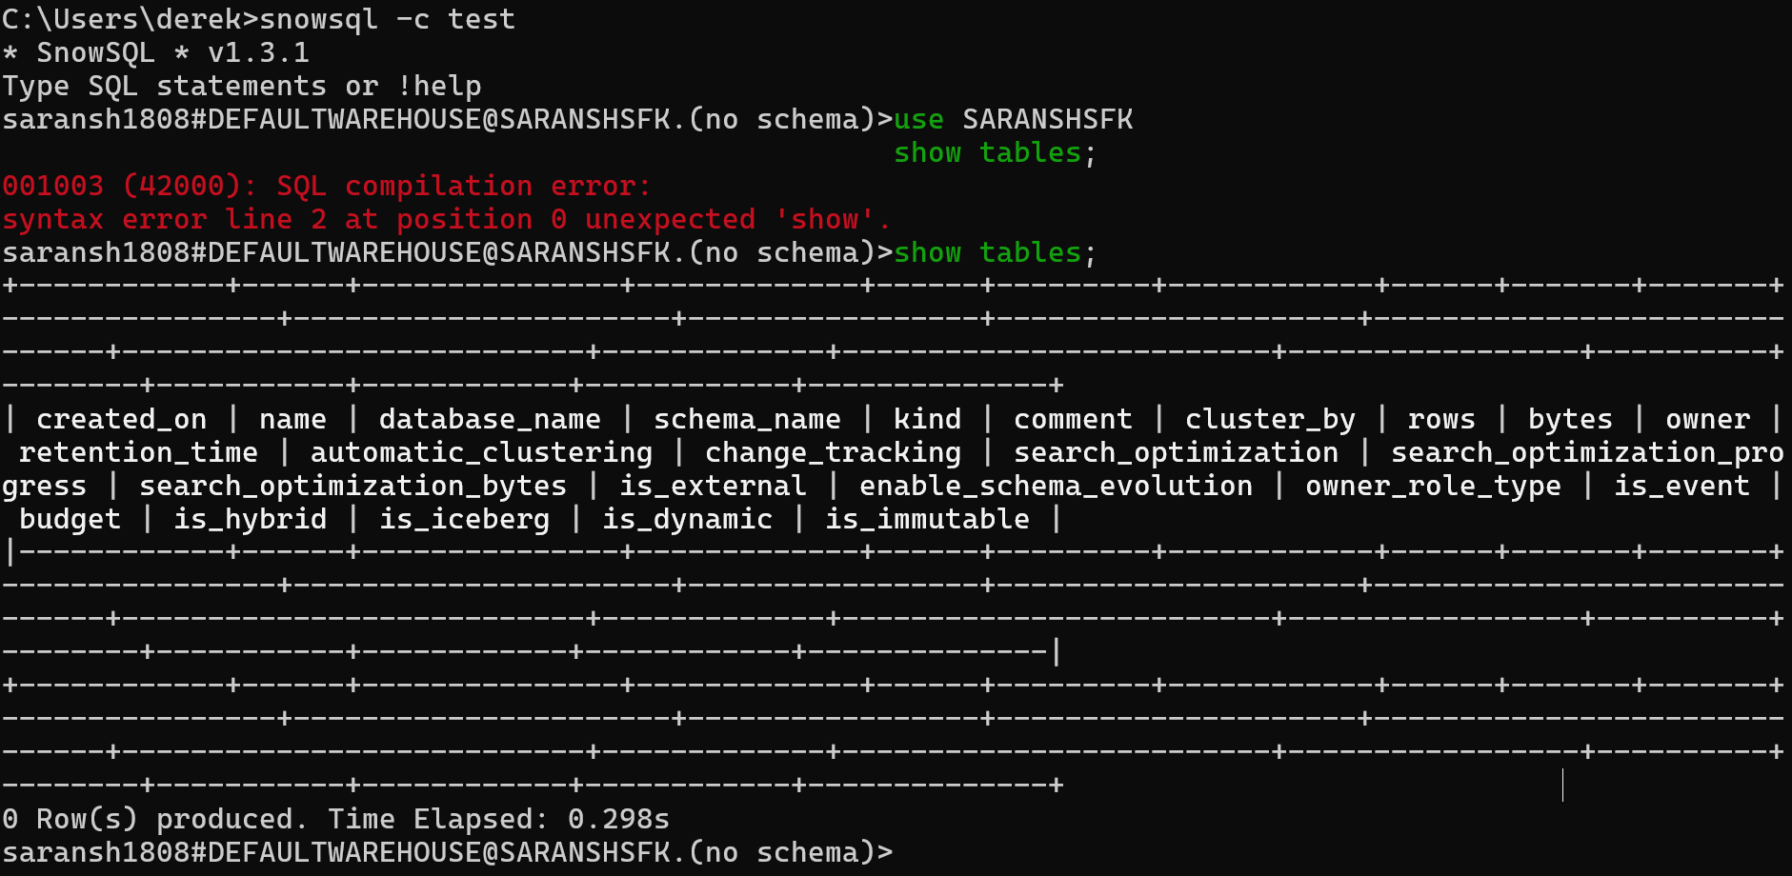

Happy Cloud computing

Regards

Saransh Jain